**Greedy Algorithm**

**Definition:**

Greedy algorithm is defined as a method for solving optimization problems by taking decisions that result in the most evident and immediate benefit irrespective of the final outcome. It works for cases where minimization or maximization leads to the required solution.

**Characteristics of Greedy algorithm:**

For a problem to be solved using the Greedy approach, it must follow a few major characteristics:

* There is an ordered list of resources (profit, cost, value, etc.)
* Maximum of all the resources (max profit, max value, etc.) are taken.
* For example, in the fractional knapsack problem, the maximum value/weight is taken first according to available capacity.

**Greedy Algorithm Example:**

Some Famous problems that exhibit Optimal substructure property and can be solved using Greedy approach are –

**1) Job sequencing Problem:**

Greedily choose the jobs with maximum profit first, by sorting the jobs in decreasing order of their profit. This would help to maximize the total profit as choosing the job with maximum profit for every time slot will eventually maximize the total profit

**2) Prim’s algorithm to find Minimum Spanning Tree:**

It starts with an empty spanning tree. The idea is to maintain two sets of vertices. The first set contains the vertices already included in the MST, the other set contains the vertices not yet included. At every step, it considers all the edges that connect the two sets and picks the minimum weight edge from these edges. After picking the edge, it moves the other endpoint of the edge to the set containing MST.

How does the Greedy Algorithm works?

When the choice to apply the greedy method is made without conducting a thorough examination, the decision to utilize it can be somewhat difficult and occasionally even result in failure. In some cases taking the local best choice may lead to losing the global optimal solution.

**For example:**

* 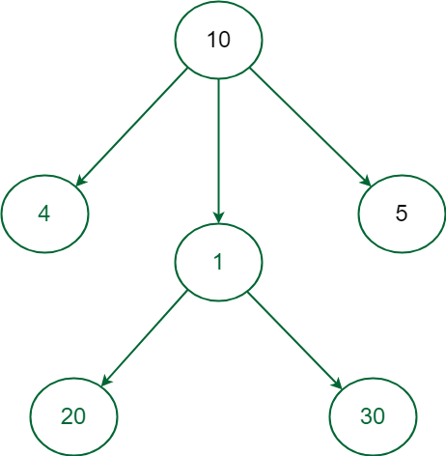*One such example where the Greedy Approach fails is to find the Maximum weighted path of nodes in the given graph.*
* *In the above graph starting from the root node 10 if we greedily select the next node to obtain the most weighted path the next selected node will be 5 that will take the total sum to 15 and the path will end as there is no child of 5 but the path 10 -> 5 is not the maximum weight path.*

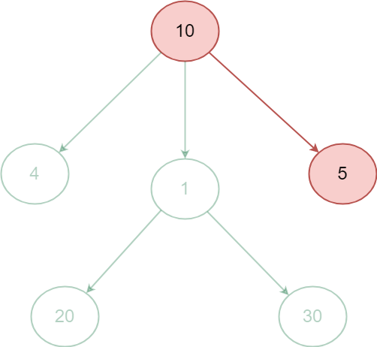

* 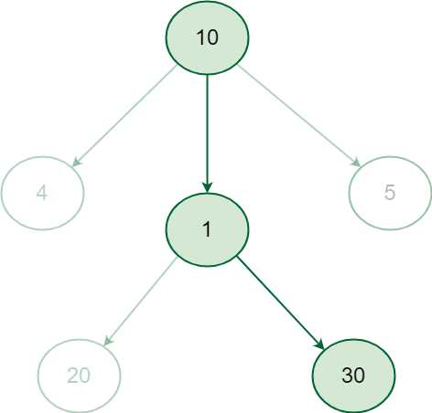*In order to find the most weighted path all possible path sum must be computed and their path sum must be compared to get the desired result, it is visible that the most weighted path in the above graph is 10 -> 1 -> 30 that gives the path sum 41.*
* *In such cases Greedy approach wouldn’t work instead complete paths from root to leaf node has to be considered to get the correct answer i.e. the most weighted path, This can be achieved by recursively checking all the paths and calculating their weight.*

**Algorithm in python:**In the following a simple example of using a Genetic Algorithm for sorting a list of numbers in Python:

def activity_selection(start, finish):

    n = len(start)

    activities = []

    i = 0

    # Select the activity with the earliest finish time

    activities.append(i)

    for j in range(n):

        # If the start time of the current activity is greater than or equal to the finish time of the last selected activity

        if start[j] >= finish[i]:

            activities.append(j)

            i = j

    return activities

# Example usage

start_times = [1, 3, 0, 5, 8, 5]

finish_times = [2, 4, 6, 7, 9, 9]

selected_activities = activity_selection(start_times, finish_times)

print("Selected activities:", selected_activities)

In this example, the activity_selection function takes two lists as input: start and finish, representing the start and finish times of the activities, respectively. The function iterates through the activities in ascending order of their finish times and selects the activity if its start time is greater than or equal to the finish time of the last selected activity.

The output of the program will be the indices of the selected activities. In this case, the output will be [0, 1, 3, 4], indicating that activities with indices 0, 1, 3, and 4 are the maximum non-overlapping activities that can be performed.

**Dynamic Algorithm**

**Definition:**

Dynamic Programming is an optimization technique used to solve complex problems by breaking them down into smaller overlapping subproblems and solving each subproblem only once. It utilizes the concept of storing the solutions to subproblems in a table or memoization array, allowing for efficient computation of the larger problem.

**Uses:**

Dynamic Programming is widely used in various domains to solve optimization problems, such as:

1. Combinatorial optimization problems: Dynamic Programming can be used to find the optimal solution for problems like the Traveling Salesman Problem, Knapsack Problem, and Graph Path Problems.
2. Sequence alignment and string-related problems: Dynamic Programming algorithms like Needleman-Wunsch algorithm and Longest Common Subsequence (LCS) can efficiently solve problems related to DNA sequence alignment, string similarity, and text comparison.
3. Resource allocation and scheduling: Dynamic Programming techniques can be applied to problems involving resource allocation, project scheduling, and production planning to optimize resource utilization and minimize costs.

**Benefits:**

Dynamic Programming offers several benefits:

1. Optimal substructure: Dynamic Programming solves subproblems optimally and combines them to find the optimal solution to the larger problem.
2. Overlapping subproblems: Dynamic Programming avoids redundant computation by storing the solutions to subproblems in a table or memoization array, ensuring that each subproblem is solved only once.
3. Efficiency: By avoiding redundant computation, Dynamic Programming can significantly improve the efficiency of solving complex problems, often leading to polynomial-time algorithms.
4. Versatility: Dynamic Programming is a versatile technique that can be applied to a wide range of problems across various domains, making it a powerful tool in algorithm design.

**Approaches:**

There are two common approaches to solving problems using Dynamic Programming:

1. Top-down approach (Memoization): In this approach, the larger problem is recursively divided into smaller subproblems, and the solutions to these subproblems are stored in a memoization table or cache. Before solving a subproblem, the algorithm checks if its solution already exists in the cache. If so, it retrieves the solution; otherwise, it computes the solution and stores it for future use. This approach is well-suited for problems with overlapping subproblems.
2. Bottom-up approach (Tabulation): In this approach, the smaller subproblems are solved first, and their solutions are iteratively computed and stored in a table or array. The algorithm starts with the base cases and progressively builds up to the larger problem. This approach is also known as the iterative approach and is often more efficient in terms of space complexity compared to the top-down approach.

**Complexity:**

The time complexity of a dynamic programming algorithm depends on the number of subproblems that need to be solved. In general, if there are n subproblems and each subproblem can be solved in O(1) time, the overall time complexity of the dynamic programming algorithm is O(n). However, the actual time complexity can vary depending on the problem and the efficiency of solving each subproblem. In some cases, dynamic programming algorithms can have exponential time complexity if the number of subproblems grows exponentially with the input size. To optimize the time complexity, techniques such as memoization or more efficient algorithms and data structures may be employed.

**Code Example:**

In the followin an example of a Dynamic Programming algorithm for solving the Fibonacci sequence using the bottom-up (tabulation) approach:

def fibonacci(n):

    fib = [0, 1]  # Base cases

    for i in range(2, n+1):

        fib.append(fib[i-1] + fib[i-2])

    return fib[n]

# Example usage:

n = 6

result = fibonacci(n)

print("The", n, "th Fibonacci number is:", result)

In this example, the Fibonacci function calculates the Fibonacci number at position n using a bottom-up approach. It iteratively computes and stores the Fibonacci numbers in the fib_table, starting from the base cases (0 and 1) up to the desired position n. Finally, it returns the Fibonacci number at position n.

**Genetic Algorithm**

**Definition:**

Genetic Algorithms (GAs) are search and optimization algorithms inspired by the process of natural selection and genetics. They are used to find approximate solutions to complex problems by imitating the principles of evolution, such as selection, crossover, and mutation. GAs operate on a population of individuals, where each individual represents a potential solution to the problem at hand . In the context of sorting, GAs can be used to arrange a collection of elements in a specific order, such as ascending or descending, based on their fitness evaluation.

**Uses:**

Genetic Algorithms are versatile and can be applied to a wide range of problems, including:

1. Optimization problems: GAs are commonly used to find optimal or near-optimal solutions in problems such as function optimization, parameter tuning, and scheduling.
2. Machine learning and data mining: GAs can be used to optimize the parameters or structure of machine learning models, such as neural networks or decision trees.
3. Game playing and strategy optimization: GAs can be employed to evolve strategies for playing games, such as chess or poker, by searching for the best combinations of moves.
4. Sorting with constraints: GAs can handle sorting problems with specific constraints. For instance, if you need to sort elements while considering limited memory or processing power, GAs can help find an optimal solution within those constraints.
5. Sorting with constraints: GAs can handle sorting problems with specific constraints. For instance, if you need to sort elements while considering limited memory or processing power, GAs can help find an optimal solution within those constraints.

**Complexity:**

The time complexity of Genetic Algorithms depends on several factors, including the problem size, population size, and the complexity of the fitness evaluation function. In general, GAs are computationally expensive, especially for large-scale problems, as they involve the evaluation of multiple individuals over multiple generations. The runtime complexity of GAs is often considered to be high, typically exponential or polynomial depending on the specific problem and implementation details.

**Code Example:**

In the following a simple example of a Genetic Algorithm implementation in Python using a binary chromosome representation:

import random

def create_individual(data):

    return random.sample(data, len(data))

def evaluate_fitness(individual):

    # In this example, the fitness is the number of elements in their correct positions

    fitness = sum(1 for i in range(len(individual)) if individual[i] == i)

    return fitness

def crossover(parent1, parent2):

    crossover_point = random.randint(1, len(parent1) - 1)

    child = parent1[:crossover_point]

    child.extend(gene for gene in parent2 if gene not in child)

    return child

def mutate(individual, mutation_rate):

    for i in range(len(individual)):

        if random.random() < mutation_rate:

            j = random.randint(0, len(individual) - 1)

            individual[i], individual[j] = individual[j], individual[i]

def genetic_sort(data, population_size, mutation_rate, generations):

    population = [create_individual(data) for _ in range(population_size)]

    for _ in range(generations):

        population = sorted(population, key=evaluate_fitness, reverse=True)

        best_individual = population[0]

        new_population = [best_individual]

        for _ in range(population_size - 1):

            parent1 = random.choice(population)

            parent2 = random.choice(population)

            child = crossover(parent1, parent2)

            mutate(child, mutation_rate)

            new_population.append(child)

        population = new_population

    sorted_data = sorted(population, key=evaluate_fitness, reverse=True)[0]

    return sorted_data

# Example usage

data = [5, 2, 9, 1, 3]

population_size = 100

mutation_rate = 0.01

generations = 100

sorted_data = genetic_sort(data, population_size, mutation_rate, generations)

print("Sorted data:", sorted_data)

In this example, the Genetic Algorithm is used to sort a list of numbers. The create_individual function generates an individual with a random permutation of the input data. The evaluate_fitness function calculates the fitness of an individual as thenumber of elements in their correct positions. The crossover function performs a single-point crossover between two parents, and the mutate function introduces random swaps between elements based on a given mutation rate.

**Foundation of Genetic Algorithms**

Genetic algorithms are based on an analogy with genetic structure and behaviour of chromosomes of the population. Following is the foundation of GAs based on this analogy –

Individual in population compete for resources and mate

Those individuals who are successful (fittest) then mate to create more offspring than others

Genes from “fittest” parent propagate throughout the generation, that is sometimes parents create offspring which is better than either parent.

Thus each successive generation is more suited for their environment.

**Search space**

The population of individuals are maintained within search space. Each individual represents a solution in search space for given problem. Each individual is coded as a finite length vector (analogous to chromosome) of components. These variable components are analogous to Genes. Thus a chromosome (individual) is composed of several genes (variable components).

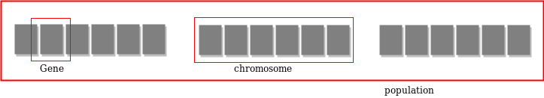

**Fitness Score**

A Fitness Score is given to each individual which shows the ability of an individual to “compete”. The individual having optimal fitness score (or near optimal) are sought.

The GAs maintains the population of n individuals (chromosome/solutions) along with their fitness scores. The individuals having better fitness scores are given more chance to reproduce than others. The individuals with better fitness scores are selected who mate and produce better offspring by combining chromosomes of parents. The population size is static so the room has to be created for new arrivals. So, some individuals die and get replaced by new arrivals eventually creating new generation when all the mating opportunity of the old population is exhausted. It is hoped that over successive generations better solutions will arrive while least fit die.

Each new generation has on average more “better genes” than the individual (solution) of previous generations. Thus, each new generations have better “partial solutions” than previous generations. Once the offspring produced having no significant difference from offspring produced by previous populations, the population is converged. The algorithm is said to be converged to a set of solutions for the problem.

**Operators of Genetic Algorithms**

Once the initial generation is created, the algorithm evolves the generation using following operators –

1. **Selection Operator:** The idea is to give preference to the individuals with good fitness scores and allow them to pass their genes to successive generations.
2. **Crossover Operator:** This represents mating between individuals. Two individuals are selected using selection operator and crossover sites are chosen randomly. Then the genes at these crossover sites are exchanged thus creating a completely new individual 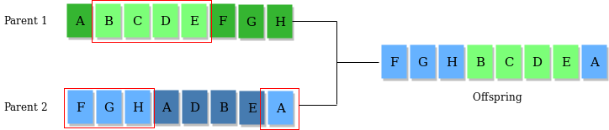(offspring). For example –
3. 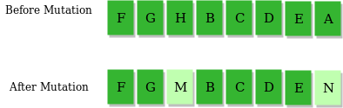**Mutation Operator:** The key idea is to insert random genes in offspring to maintain the diversity in the population to avoid premature convergence. For example –

**The whole algorithm can be summarized as –**

1) Randomly initialize populations p

2) Determine fitness of population

3) Until convergence repeat:

a) Select parents from population

b) Crossover and generate new population

c) Perform mutation on new population

d) Calculate fitness for new population